Installations and Configurations

**Testing Motors Rotation:**

**Installations:**

* sudo apt install -y git python3 python3-pip python3-dev python3-setuptools python3-wheel \

python3-opencv python3-pyqt5 python3-serial python3-pyulog python3- pymavlink

* sudo apt install -y python3-pymavlink python3-opencv python3-serial
* git clone <https://github.com/ArduPilot/pymavlink.git>
* cd pymavlink
* pip3 install .
* git clone <https://github.com/ArduPilot/MAVProxy.git>
* cd mavproxy
* pip3 install .

Use a **USB-to-Telemetry (USB-TTL)** cable to connect Pi 5 to the **TELEM2 port** of the Orange Cube Plus.

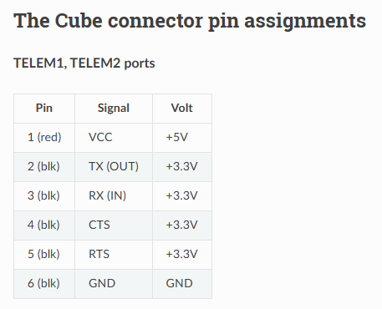

**Parameter settings in Mission Planner:**

1.serial_2 set it to 2 to enable mavlink

2. All other serial channels to 0

**Connect Raspberry pi via ssh:**

->ssh [pi@192.168.75.59](mailto:pi@192.168.75.59)

->password:1234

->ls -l /dev/ttyUSB*

o/p: crw-rw---- 1 root dialout 188, /dev/ttyUSB1 or USB0(check the correct USB port and put in the following command)

You can check the port by : ls /dev/ttyUSB*

In my case its USB1

->mavproxy.py --master=/dev/ttyUSB1 --baudrate 57600 or 115200 --aircraft mydrone

->mode stabilize

->arm check

->arm throttle (Arm)

-> rc 3 1700 (Arm Fast)

->rc 3 100 (Disarm slowly)

**1.MAVProxy Startup Commands:**

1.1. Connect to the Flight Controller

**mavproxy.py --master=/dev/ttyUSB1 --baudrate 57600 --aircraft mydrone**

* --master=/dev/ttyUSB1 → Specifies the USB port of the Pixhawk (change it if needed).
* --baudrate 57600 → The communication speed (baud rate) between Raspberry Pi and the flight controller.
* --aircraft mydrone → Names the aircraft directory for logs and configurations.

**2. Flight Mode Commands**

These commands change the flight mode of your drone.

2.1. Check Available Flight Modes

**mode**

Displays a list of available flight modes.

2.2. Change Flight Mode

**mode STABILIZE**

* STABILIZE → Manual control with auto-leveling.
* ALT_HOLD → Maintains altitude using a barometer.
* LOITER → Holds position using GPS.
* AUTO → Autonomous flight based on a pre-planned mission.
* GUIDED → Executes real-time commands from a ground station.
* RTL → Returns to the home position.

**3. Arming & Disarming the Drone**

Before taking off, you need to arm the drone.

3.1. Check If Arming is Allowed

**arm check**

Verifies if all pre-arm safety checks pass.

3.2. Arm the Drone

**arm throttle**

Arms the drone motors, allowing them to spin.

3.3. Arm and Increase Throttle (Takeoff)

**rc 3 1700**

* rc 3 1700 → Sets channel 3 (throttle) to 1700 (higher value for faster motor spin).

3.4. Disarm the Drone

**rc 3 100**

* rc 3 100 → Gradually lowers throttle to 100 (disarm slowly).

**4. Radio Control (RC) Commands**

You can manually control the drone using RC (Radio Control) commands.

4.1. Change RC Channel Values

**rc <channel> <value>**

Example:

**rc 1 1500** # Move roll to neutral

**rc 2 1500** # Move pitch to neutral

**rc 3 1700** # Increase throttle

**rc 4 1500** # Set yaw to neutral

* Channels:
  + 1 = Roll (left/right movement)
  + 2 = Pitch (forward/backward movement)
  + 3 = Throttle (altitude control)
  + 4 = Yaw (rotation)